**DIGITAL SIGNAL PROCESSING LAB**

**Fall 2024, 5th Semester**

**Lab Report 1**



# Submitted by: **Hassan Zaib Jadoon**

Registration Number**: 22PWCSE2144**

Section: **A**

“On my honor, as a student at the University of Engineering and Technology

Peshawar, I have neither given nor received unauthorized assistance on this academic work.”

**Submitted To: Dr. Yasir Saleem Afridi**   
**Department of Computer Systems Engineering**  
**University of Engineering and Technology Peshawar**

**Lab Report**

**Signal Analysis in both time and frequency domain using MATLAB**

* **Provide a .m file with detailed comments**

1. Will generate the signal of different frequencies say, 10,20,30,40,50,60 Hz (one second duration) using MATLAB as shown in figure 1 and transform the same signal in frequency domain using Fourier transform and will compare the frequencies with the time domain signal as shown in figure 2.

Code:

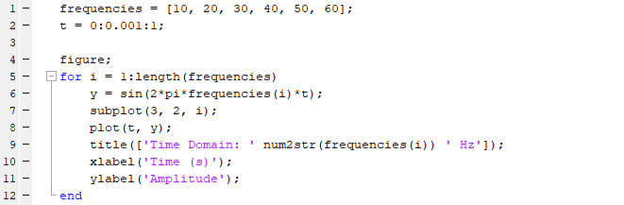

Output:

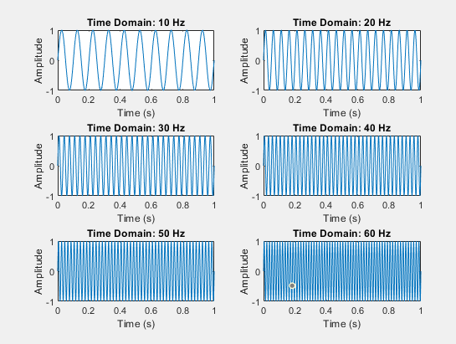

**Comments:**

1. Compare the Figures 1 and 2 (Generated by your code):

Code:

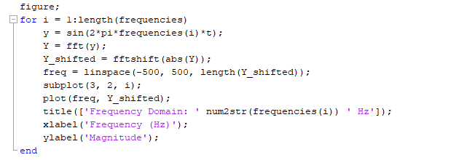

Output:

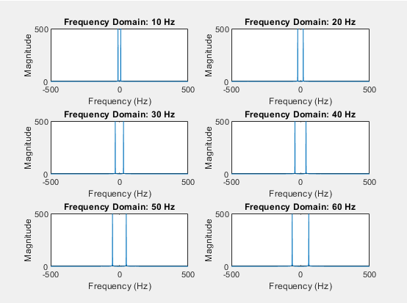

Remarks:

1. Add all the signals generated in step 1 and get a composite signal. (which may be considered as a voice signal)

Code:

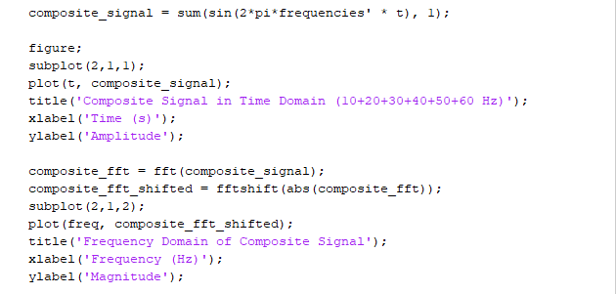

Output:

Remarks:

Generate some unwanted signal having frequencies say 80Hz and 100Hz (assume these signals represent noise) and different amplitudes say 0.5 and 0.7:

Code:

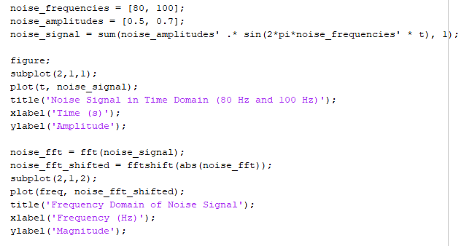

Output:

Remarks:

Add the noise to the composite signal (assume the noise is added to the signal during transmission) and obtain frequency spectrum:

Code:

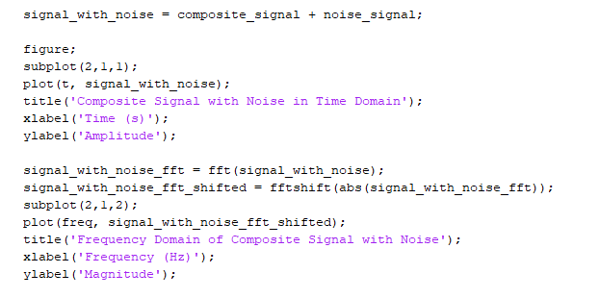

Output:

Remarks:

Conclusion:

**CSE 402L: Digital Signal Processing**

|  |  |  |  |  |
| --- | --- | --- | --- | --- |
| **Demonstration of Concepts** | **Poor (Does not meet expectation (1))**  The student failed to demonstrate a clear understanding of the assignment concepts | **Fair (Meet Expectation (2-3))**  The student demonstrated a clear understanding of some of the assignment concepts | **Good (Exceeds Expectation (4-5)**  The student demonstrated a clear understanding of the assignment concepts | **Score**  **30%** |
| **Accuracy** | The student completed ( <50%) tasks and provided MATLAB code and/or Simulink models with errors. Outputs shown are not correct in form of graphs (no labels) and/or tables along with incorrect analysis or remarks. | The student completed partial tasks (50% - <90%) with accurate MATLAB code and/or Simulink models. Correct outputs are shown in form of graphs (without labels) and/or tables along with correct analysis or remarks. | The student completed all required tasks (90%-100%) with accurate MATLAB code and/or Simulink models. Correct outputs are shown in form of labeled graphs and/or tables along with correct analysis or remarks. | **30%** |
| **Following Directions** | The student clearly failed to follow the verbal and written instructions to successfully complete the lab | The student failed to follow the some of the verbal and written instructions to successfully complete all requirements of the lab | The student followed the verbal and written instructions to successfully complete requirements of the lab | **20%** |
| **Time Utilization** | The student failed to complete even part of the lab in the allotted amount of time | The student failed to complete the entire lab in the allotted amount of time | The student completed the lab in its entirety in the allotted amount of time | **20%** |